AI Interactive Companion Doll - User Manual

Contents:
- Product Overview
- System Requirements
- Quick Start Guide
- Features & Functions
- Troubleshooting

1. Product Overview

1.1 Introduction
The AI Interactive Companion Doll represents the next generation in smart companionship technology. Powered by advanced AI voice interaction and deep learning algorithms, it provides a highly engaging, human-like experience. Key features include:
- Advanced emotion recognition and expression
- Adaptive conversation capabilities
- Immersive interactive dialogue
- Personalized companionship through continuous AI learning

1.2 What's in the Box
The package includes the following items:
- AI Interactive Companion Doll
- USB Type-C Charging Cable
- User Manual
- Warranty Card
- Doll Too l App (Downloadable)

1.3 Key Features
- Real-time voice interaction
- Multi-scenario conversations
- Customizable voice options
- Emotional intelligence
- WiFi connectivity

2. System Requirements

2.1 Network Requirements
2.1.1 Basic Network Specifications
- WiFi: 2.4GHz network only (5GHz is not supported)
- Recommended Internet Speed: 10Mbps or higher
- Signal Strength: 3 bars or more recommended
- Connection Stability: Stable connection required (avoid networks with frequent dropouts)
2.1.2 Router Setup Tips
- Keep the device within 30 feet of the router
- Avoid placing it in WiFi dead zones
- Minimize walls between device and router
- Keep away from metal objects that may interfere with the signals

2.2 Audio Environment Guidelines
2.2.1 Noise Control
- Keep background noise below 60dB
- Optimal interaction distance: Within 10 feet
- Avoid rooms with heavy echo
- Best used in enclosed spaces
2.2.2 Common Interference Sources to Avoid
- Constant noise: AC units, fans
- Sudden sounds: Doorbells, phone rings
- Other audio devices: TVs, speakers
- Crowded, noisy environments

3. Quick Start Guide

3.1 First-Time Setup
3.1.1 Powering On
- Press and hold the power button for 2 seconds.
- Watch for the indicator light.
- Red light + voice prompt: "Hello, nice to meet you!"
3.1.2 Charging Instructions
- Fully charge before first use (2-3 hours).
- Light indicators:
  - Red: Charging in progress
  - Green: Fully charged

3.2 App Installation
3.2.1 Getting the App
- Scan the QR code or visit: https://www.lovedoll.chat/DollTool/

- iOS: Search for "Doll Tool" in the App Store
3.2.2 System Requirements
- Enable Bluetooth
- Allow requested app permissions

3.3 Account Setup
3.3.1 New Account Registration
- Select interface language
- Click "other login methods" to access the Register Page
- Select your area in Register Page
- Enter your email address
- Create a password
- Click "Get Verification Code" and check your email for the code
- Enter the verification code
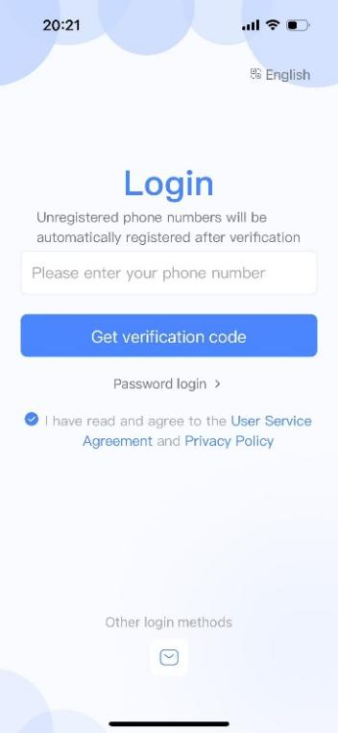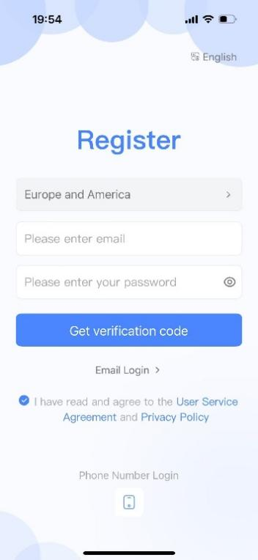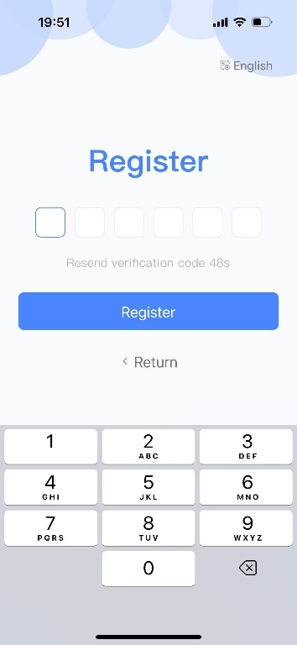
3.3.2 Login Options
- Password login (after initial registration)
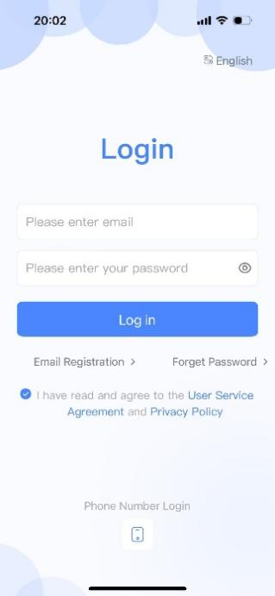

3.4 Device Connection
3.4.1 Preparation
- Ensure device is in pairing mode (blinking blue light)
- Connect phone to 2.4GHz WiFi
- Enable Bluetooth
- Keep the app open
3.4.2 Connection Steps
- Click "Add Device" in the app
- Select your device
- Enter WiFi password
*Both WiFi credentials (SSID and password) are case-sensitive. Ensure exact matching of uppercase and lowercase characters to avoid connection errors.
- Wait for connection completion
- Device will auto-connect to server and complete binding
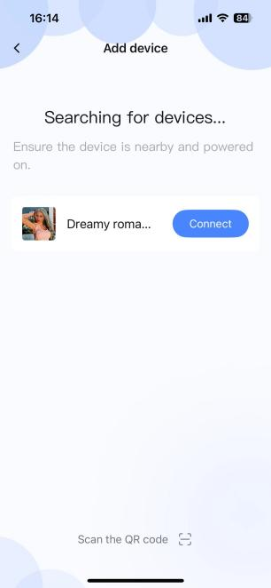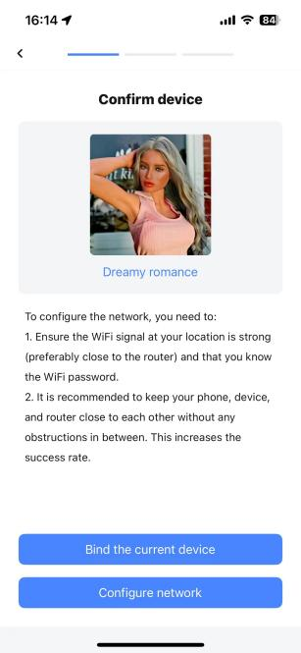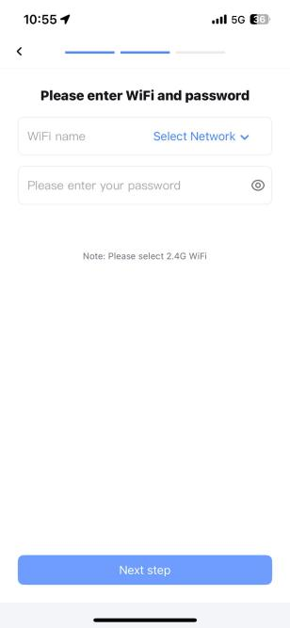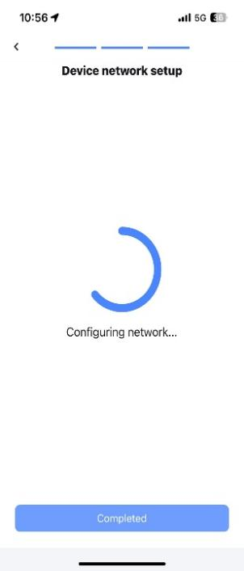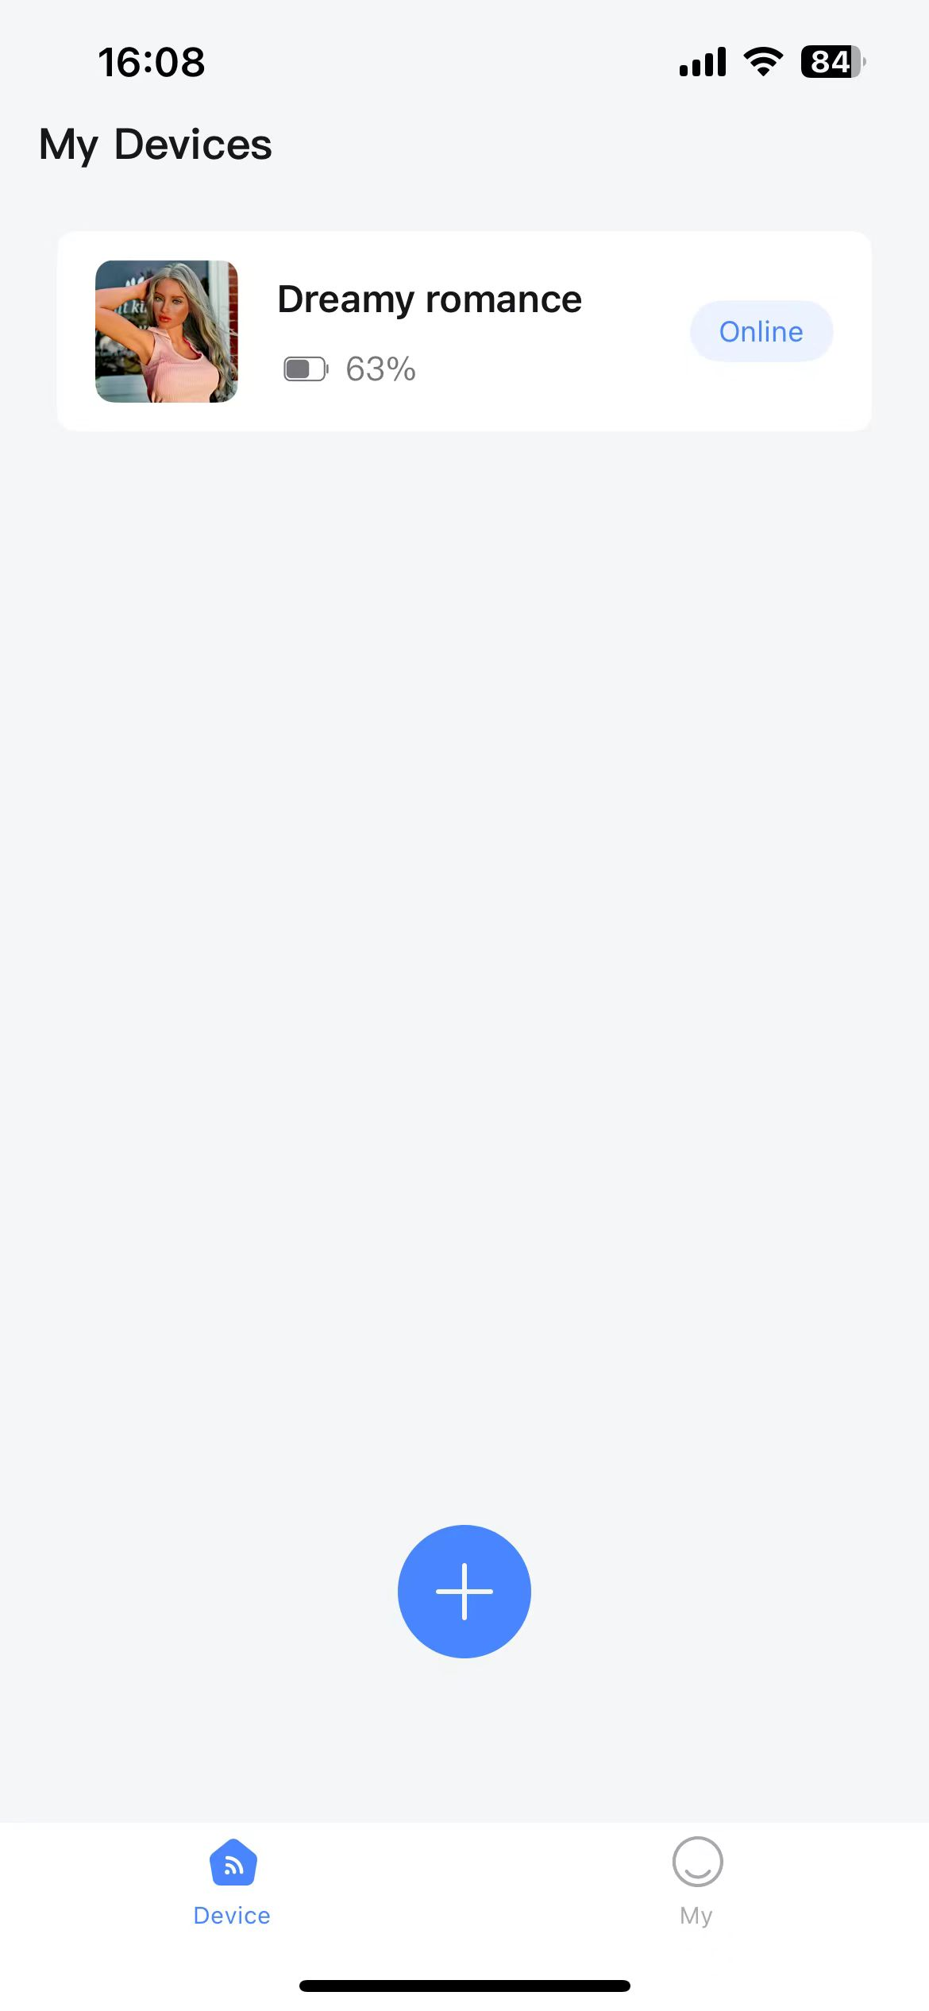

3.5 Basic Functions
3.5.1 First Conversation
- Say wake word: "Hello-Baby" (voice command to activate the device)
- Try these basic commands:
  - "What's the weather today?"
  - "What time is it?"
3.5.2 Volume Control
- Voice commands:
  - "Volume up" or "Volume down"
  - Device will confirm with a sound

3.6 Important Tips
- Ensure stable internet connection
- First use in a quiet environment
- Speak clearly
- Stay within recommended distance

3.7 Quick Setup Checklist
- Fully charged
- App installed
- Account created
- WiFi connected
- Wake word works
- Basic functions tested

4. Detailed Features

4.1 Voice Interaction Basics
4.1.1 Wake Function
- Default wake word: "Hello-Baby"
- Confirmation sound: Device chimes when activated
- Active listening period: 3 minutes
- Sleep mode: Activates after 3 minutes of inactivity
- Interrupt feature: Use wake word anytime to stop current response
Device Settings Menu:
- Battery level indicator
- Role switch
- Device sound switch
- Prompts language switch
- Device heating switch
- Change device volume
- Firmware info
- Unbind device
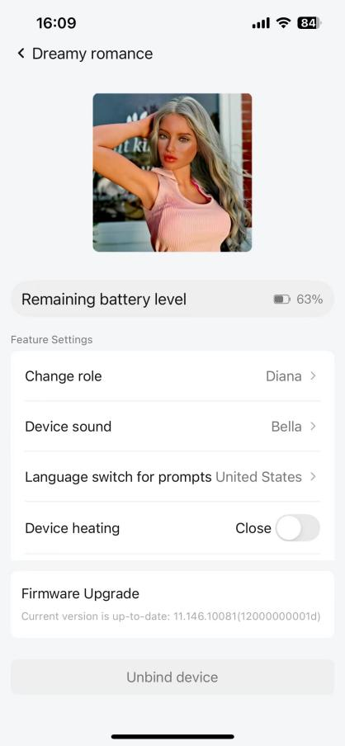

4.1.2 Basic voice control (triggered by similar semantics)

- Volume control
- Turn up the volume
- Volume up
- Volume increase
- Increase the volume
- Volume reduction
- Turn down the volume
- volume down
- turn down
- Maximum volume
- The highest volume
- Fully open the volume
- Lowest volume
- Volume fully turned off
- Adjust the volume to N percent (N can make 0,10,20,100)
- Volume increase by N percent (N can make 0,10,20,100)
- Scene switching control
- Go to the living room
- a living room
- Moving to the living room
- Come to the living room
- Walk towards the living room
- Enter the living room
- Move to the living room
- Go to the living room
bedroom
- Enter the bedroom
- Go to the bedroom
- Enter the master bedroom

- Sound effects control
- Call it, call it
- I need you now
- I like to see your expression like this
- I will love you well
- I like watching you twist like this
- Your little mouth is so sweet, it makes me want to kiss you
- Make me want to delve deeper into you
- I'm having a great time
- Your voice makes me even more excited
- Shout louder again
- I want you to taste my strength

4.2 App Control Features

4.2.1 Device Management
- One user per device binding
- Unbind device before sharing
- Long-press the device icon for options:
  - Delete device
  - Rename device
  - Online/offline status indicators
  - Auto-reconnect attempts for 2 minutes before showing offline status

4.3 Usage Guidelines

4.3.1 Daily Maintenance
- Keep the device clean
- Charge regularly
- Update firmware when available
- Maintain a proper environment
4.3.2 Best Practices
- Start with basic commands
- Gradually explore advanced features
- Save frequently used commands
- Develop consistent usage patterns

5. Troubleshooting Guide

5.1 Basic Device Issues
5.1.1 Power Problems
Q: Device won't turn on?
  - Check these steps:
    - Connect charger to verify battery level
    - Press power button for at least 2 seconds
Q: Device shuts down unexpectedly?
  - Common solutions:
    - Low battery → Charge device
    - System error → Restart and update firmware

5.2 Voice Interaction Issues
5.2.1 Wake Word and Recognition
Q: Device not responding to wake word?
  - Check the following:
    - Background noise level
    - Correct wake word usage
    - Distance from device (stay within 3 feet)
    - Device operating status
Q: Poor voice recognition?
  - Try:
    - Speak clearly
    - Avoid speaking too fast
    - Use in a quiet environment
    - Adjust position relative to device

5.3 Network Connection Issues
5.3.1 Connection Failures
- Q: Can't connect to WiFi?
  - Troubleshooting steps:
    - Confirm 2.4GHz WiFi network
    - Verify WiFi password
    - Enable Bluetooth
    - Check pairing mode
    - Restart router
    - Tip: Double-click power button to toggle Bluetooth
    - Android phone hotspot settings: Ensure that the phone hotspot works in 2.4GHz network mode
    - iOS Phone Hotspot Settings: When turning on the hotspot, please ensure that the maximum
    - Enter WIFI password, pay attention to case sensitivity, it is related to the success or failure of network connection.
    - When the device is in motion, it will disconnect if the network environment is poor, and it will automatically reconnect when it reaches a good network environment. This may affect the use. It is recommended to maintain a stable network environment.
5.3.2 Device Offline
- Q: Frequent disconnections?
  - Solutions:
    - Check WiFi signal strength
    - Reconnect to network

5.4 App Issues
5.4.1 App Problems
- Q: App not working properly?
  - Try these steps:
    - Check internet connection
    - Clear app cache
    - Restart app
    - Update to the latest version
    - Uninstall and reinstall
5.4.2 Account Issues
- Q: Not receiving verification code?
  - Solutions:
    - Verify that the email verification code is correct
    - Check whether the mailbox is blocked
    - Wait 60 seconds and try again
5.5 Device Binding and Status
5.5.1 Device Binding Rules
Q: Why can't I bind the device?
A: Please note the following rules:
- One device can only be bound to one user.
- Devices that are already bound to other users cannot be bound.
- To change the user, the original user must first unbind the device.
Q: How do I manage bound devices?
A: Follow these instructions:
Long press the device icon to:
  - Delete the device (this will also unbind it)
  - Rename the device
To unbind the device:
  - Go to Device Settings
  - Select "Unbind Device"
  - Confirm the unbinding operation

5.5.2 Device Status Explanation
Q: What are the device status indicators?
A: Here are the status explanations:
- Bound Status
  - Once successfully bound, the device will immediately show "Online"
  - The device is ready for normal use
- Offline Status
  - The device will automatically attempt to reconnect after disconnecting
  - If reconnection fails for 2 minutes, it will display "Offline"
  - If offline, check the network connection
- Sleep Mode
  - The device will enter sleep mode after 3 minutes of inactivity
  - The device can enter sleep mode automatically by issuing the voice commands "goodbye dear".
  - When the device is in sleep mode, say "HELLO - Baby" to wake it up for further use.
  - Sleep mode effectively saves battery power and extends the device's usage time.

